|  |  |
| --- | --- |
|  | Faculty of Information Science and Technology  Universiti Kebangsaan Malaysia  43600 Bangi Selangor |
| **TTTK2103**  **Computer Network Technology** | |

**PACKET TRACER**

2.5.5 Packet Tracer - Configure Initial Switch Settings

|  |  |
| --- | --- |
| **Name** | **Matrix Number** |
| Mariam binti Masuan | A182976 |
| Mohamad Saiful Nizam bin Abd Aziz | A179830 |

**2.5.5 Packet Tracer - Configure Initial Switch Settings**

**Part 1: Verify the Default Switch Configuration**

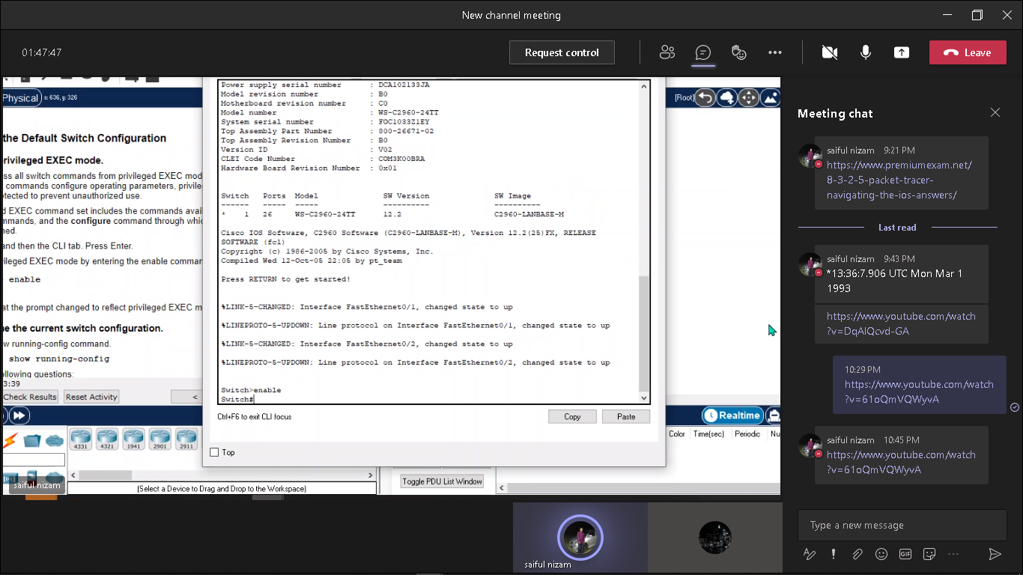 **Step 1: Enter privileged EXEC mode.**

**Step 2: Examine the current switch configuration.**

**a. How many Fast Ethernet interfaces does the switch have?**

Answer: 24

b.**How many Gigabit Ethernet interfaces does the switch have?**

Answer: 2

**c.What is the range of values shown for the vty lines?**

Answer: 0-15

**d.Which command will display the current contents of non-volatile random- access memory (NVRAM)?**

Answer: show startup-configuration

**e.Why does the switch respond with “startup-config is not present?”**

**Answer:** Because the configuration file was not saved to NVRAM. Currently it is only located in RAM.

**Part 2: Create a Basic Switch Configuration**

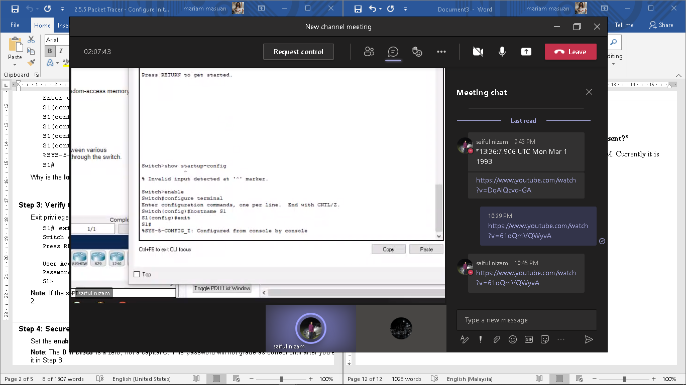 **Step 1: Assign a name to a switch.**

**Step 2: Secure access to the console line.**

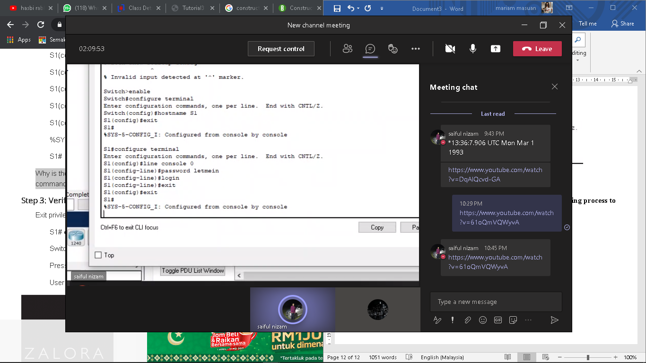

**Why is the login command required?**

Answer: In order for the password checking process to work, it requires both the login and password commands.

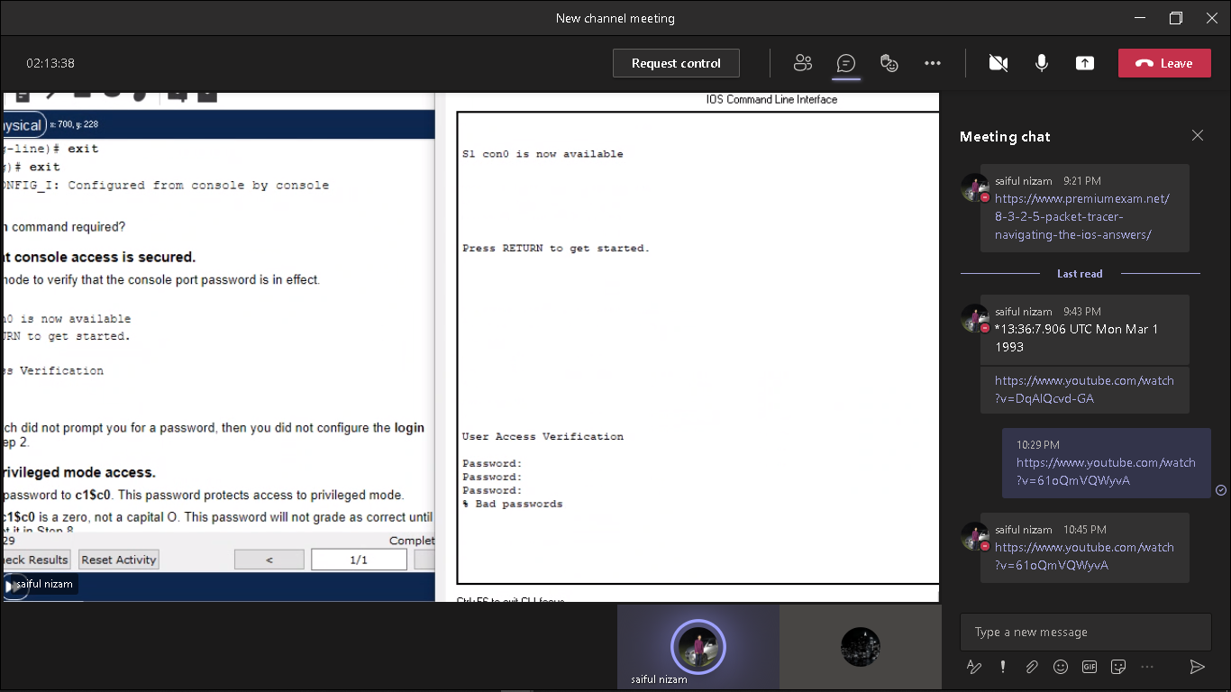 **Step 3: Verify that console access is secured.**

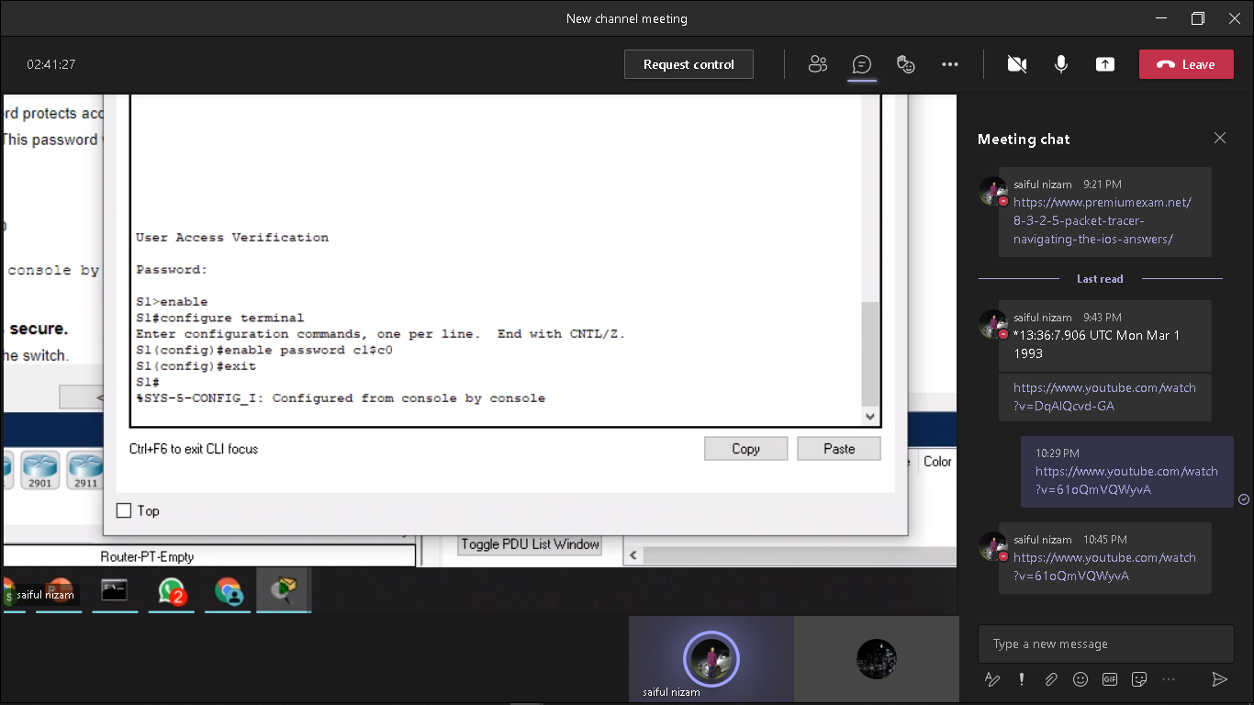  **Step 4: Secure privileged mode access.**

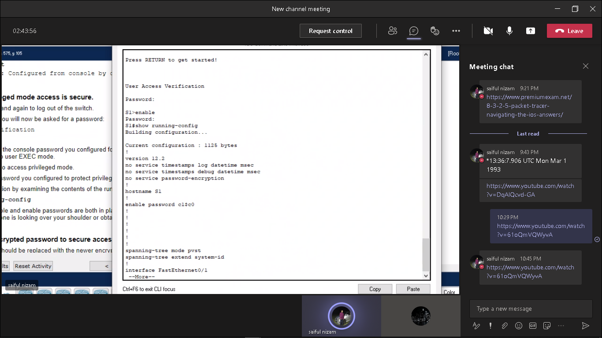 **Step 5: Verify that privileged mode access is secure.**

**Step 6: Configure an encrypted password to secure access to privileged mode.**

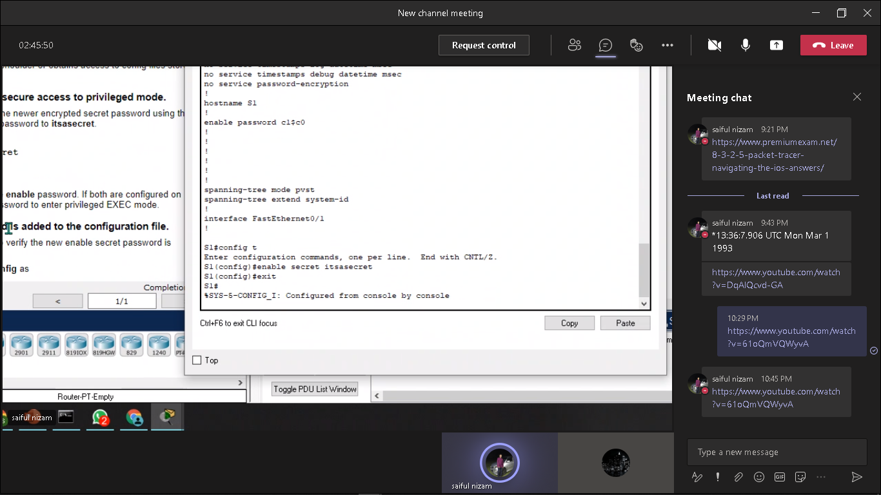

**Step 7: Verify that the enable secret password is added to the configuration file.**

**What is displayed for the enable secret password?**

Answer: $1$mERr$ILwq/b7kc.7X/ejA4Aosn0

**Why is the enable secret password displayed differently from what we configured?**

Answer: The enable secret is shown in encrypted form, whereas the enable password is in plain text.

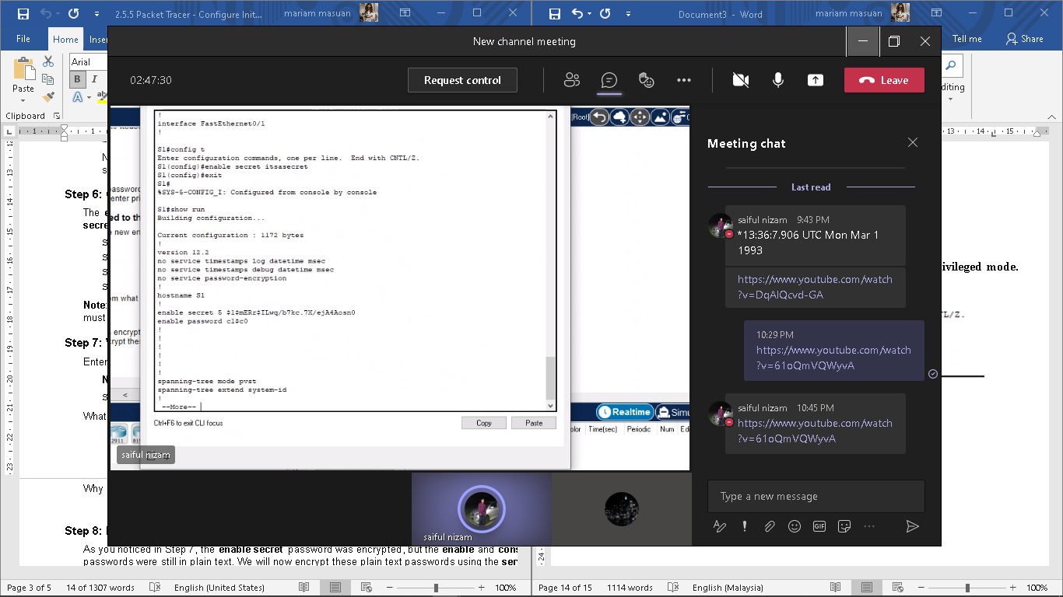

**Step 8: Encrypt the enable and console passwords.**

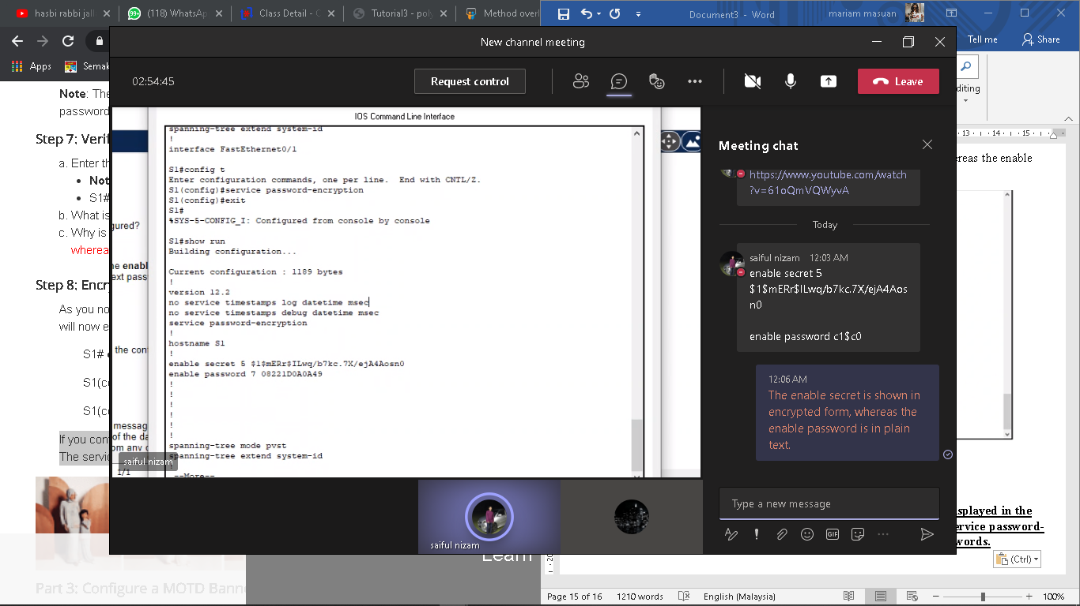

**If you configure any more passwords on the switch, will they be displayed in the configuration file as plain text or in encrypted form?**

Explain. The service password-encryption command encrypts all current and future passwords.

**Part 3: Configure a message of the day (MOTD) banner.**

**Step 1: Configure a message of the day (MOTD) banner.**

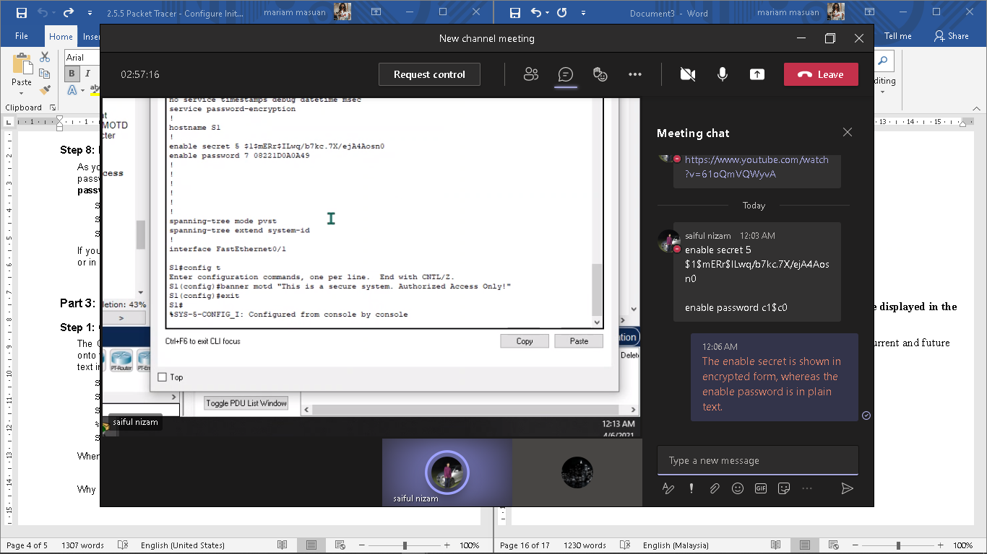

**When will this banner be displayed?**

Answer: The message will be displayed when someone enters the switch through the console port.

**Why should every switch have a MOTD banner?**

Every switch should have a banner to warn unauthorized users that access is prohibited but can also be used for sending messages to network personnel/technicians (such as impending system shutdowns or who to contact for access).

**Part 4: Save and Verify Configuration Files to NVRAM**

**Step 1: Verify that the configuration is accurate using the show run command.**

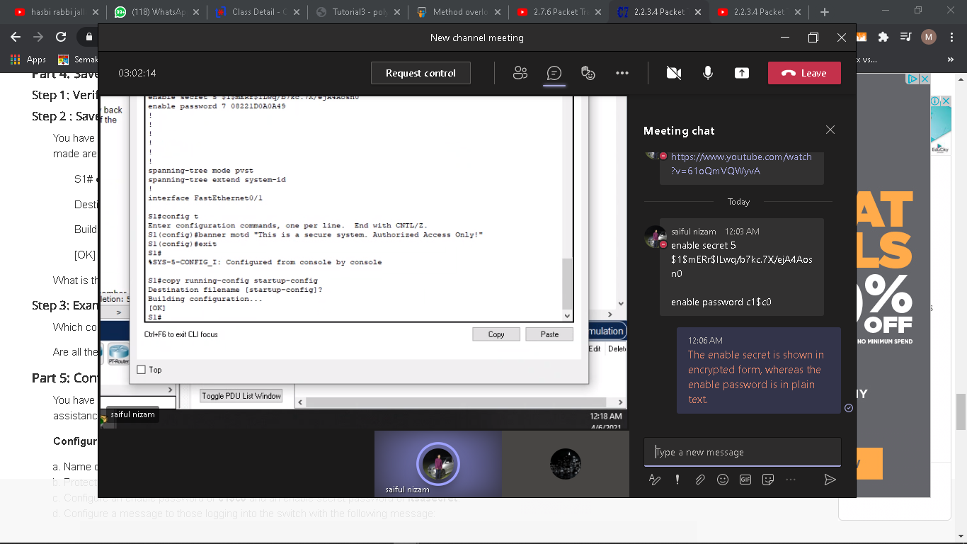

**What is the shortest, abbreviated version of the copy running-config startup- config command?**

Answer: cop r s

**Which command will display the contents of NVRAM?**

Answer: show startup-config

**Are all the changes that were entered recorded in the file?**

Answer: Yes, it is the same as the running configuration.

**Part 5: Configure S2**

